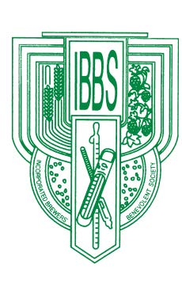

The Incorporated Brewers’ Benevolent Society

C/o The Clock House Studio

Clock House Lane

Bramley

Surrey

GU5 0AP

Telephone: 01483 893 100

[enquiries@brewbensoc.co.uk](mailto:enquiries@brewbensoc.co.uk) 01 April 2025

Following the Special IBBS Meeting help on 26 June 2024 and approval of the FAC confirming the change to Rule 6(4)(a) we invite Members of the CIBD to confirm it they wish to be a Member of the Incorporated Brewers Benevolent Society (IBBS) by providing the following information to the IBBS Secretary by Friday 4 July 2025

{*insert your name}* of {*insert your full postal address}* *being a person employed or formerly employed in the brewing and/or distilling profession in the United Kingdom or Republic of Ireland or having been a member of the International Brewers' Guild prior to the winding up of that organization or a current member of the Chartered Institute of Brewers and Distillers covering the United Kingdom or Republic of Ireland do hereby declare that I wish to continue as a member of the Society.*

Additional notices will be published in the May and June editions. You only need to respond and provide your information once before Friday 4 July. Information can either be posted or emailed to:

The Incorporated Brewers Benevolent Society

The Clock House Studio

Clock House Lane

Bramley

Surrey GU5 0AP

+ 44 1483 893 100

[enquiries@brewbensoc.co.uk](mailto:enquiries@brewbensoc.co.uk)

If you have any questions please contact the Secretary, Julie Carling, details above.